Causes of Depression and Anxiety
As we have seen, both depression and anxiety have roots in our biology and evolutionary history! So it’s good to remember that everyone experiences features of both as part of a healthy emotional response to life’s difficulties. However, not everyone experiences them severely – so what causes some people to struggle with them more than others?
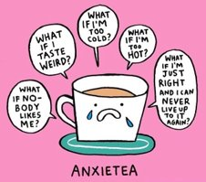
We think there are a number of causes. Your genetics play a large role: if you have a family history of mental ill health, you may inherit genes that make you more vulnerable. The chemicals in your brain play a large part too: if your brain doesn’t make enough of some neurotransmitters, such as serotonin, you may begin to feel depressed. This means that, if you take any substances that alter your brain chemistry, you could be at increased risk of depression or other mental health issues. (If you get medication, it is likely to be a kind that affects the chemicals in your brain.)
You could also have a personality type that makes you predisposed to depression or anxiety, you might have a physical health problem that affects your mental health, or you may have experienced trauma in your past that manifests as mental ill health.
Additionally, life changes could make you feel depressed: becoming unemployed, moving to a new place, or being consistently stressed. Stress is a big part of mental health – as you can see from this diagram, some stress is important to help you perform well, but too much can be a problem.
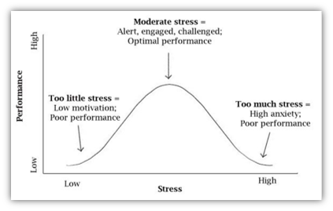
Depression and anxiety serve another useful biological purpose here: they let you know that you are overwhelmed! If you’re too stressed, as you can see on the graph, you might begin to burn out. Feeling overly depressed or anxious can be a signal that you need to take a break, and doing so might help you to feel like you’re in control again. A large part of managing your mental health is learning to be kind to yourself!

