Understanding Anxiety and Depression

What is Depression?
Depression is more than feeling unhappy or fed up for a few days, though this can be part of it. It’s normal to be sad or occasionally feel bad about something, but depression might cause you to have more negative thoughts or beliefs than usual: you might start to dislike the things in your life, activities that you used to enjoy, or even yourself. If you have been feeling sad or upset for more than two weeks, you could be experiencing depression.
The man in this video does a good job explaining some of the symptoms of depression, though they may feel different for everyone: it can make you feel lonely or isolated, and it may even make you want to hurt yourself. You may find that you have become less and less active, don’t go out much anymore, avoid hanging out with friends and stop engaging in your favourite activities. You may start to fixate on the things that you find depressing, whether these are thoughts, situations, or objects. You might judge yourself harshly or become pessimistic about the future. Depression may also cause you to worry a lot, for example about whether people like you – this is often linked to anxiety.
If you like, please write down some words to describe your experience with depression in the space below.

For me, depression is... _______________________________________________________

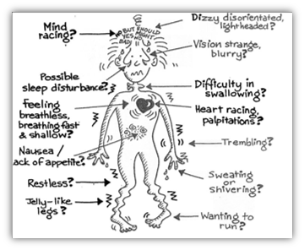
What is Anxiety?
Anxiety is not our enemy. There are lots of anxieties in life, and some of them are healthy! For example, feeling nervous before a big exam or interview is normal and shows that you care about it. In fact, being stressed about something can make you perform better! Everyone feels some degree of anxiety in everyday life, and it’s important to understand that this is normalHowever, anxiety can become a real problem if it gets severe. For instance, you may have (or know someone who has) a phobia about certain objects, or perhaps a physical health problem that may cause you pain and anxiety. Two other common versions of anxiety are Generalised Anxiety Disorder (a constant feeling of anxiety that causes mental and physical discomfort), and panic attacks (intense feelings of fear or disaster with strong physical reactions like breathlessness).
You might be familiar with these forms of anxiety. If so, you’ll probably be aware of the physical symptoms, which can include: shortness of breath, a faster heartrate, sweating, dizziness, and more. You might recognise some of these in the picture above. They can be very unpleasant and, especially in situations like panic attacks, may be a result of your body’s “fight, flight, or freeze” instincts.
If you like, please write down some words to describe your experience with anxiety in the space below.

For me, anxiety is... _______________________________________________________

Fight, Flight, or Freeze
We think that both depression and anxiety come from points in our evolution when they served a valuable purpose in keeping us safe.
In the past, if we didn't get anxious about dangerous situations we probably wouldn't live very long – so it’s part of our natural defence system.
The process of anxiety triggers the ‘fight, freeze or flight' response – a vital defence system which is common to all mammals and most other animals as well. Please watch this video to learn how it works.
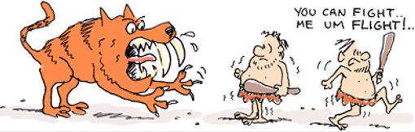
While there are no tigers today, your brain still thinks of stressful situations as physical threats and reacts in the same way! This can be difficult to handle, but we’ll learn more about how to control it in the next workshop.
Similarly, the pessimism of depression served a useful purpose when our ancestors needed to be aware of threats and dangers in the past, such as being ambushed by predators. A pessimistic outlook once helped to keep us alive - our brains often default to this worldview as a protective mechanism, even though it’s no longer useful in day-to-day life.

