Managing Depression and Anxiety
Below you will find two activities that can help with symptoms of anxiety and/or depression.

Square Breathing
The first activity we’re going to try is one designed to press the “off” switch on your flight or fight response. This is called Square Breathing, and involves taking long, deep breaths to help soothe and relax yourself when you’re feeling particularly strong emotions (for example, during a panic attack).
Square breathing is all about calm, steady rhythm. To try it, simply breathe in for 4 seconds, hold it for 4 more, breathe out for 4 seconds, and then hold your out-breath for 4 more. Have a look at the diagram below or watch this video for a clearer demonstration.
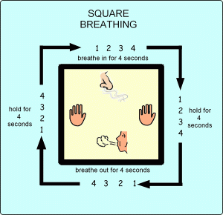
To begin with, please try to practice square breathing when you are feeling OK. This will help you to then use it if you’re feeling distressed in the future. Your breath can be an amazing tool to help anchor you in the moment and take a break from thoughts or feelings that are troubling you. For more information, please have a look at the Mindfulness workshop on our website.

Distancing from our Thoughts
This next activity is intended to help with difficult thoughts. We all struggle with unhelpful thoughts at times, and it can be useful to distance ourselves from them as this allows us to realise they are just passing ‘mental events’ in our minds. They are not facts.
This activity is simple and quick to complete, as you’ll see:
- Please take a pen and a piece of paper and write down a common negative or unhelpful thought that you often experience.
- Place the piece of paper as close as you can to your face and keep repeating the unhelpful thought in your mind. How does that feel?
- Now hold out the piece of paper with both hands, stretch out as far forward as possible and say “Sometimes I have the thought that… (unhelpful thought)”.
- Do you feel a difference?
It’s easy to think that unhelpful thoughts or beliefs are actually facts, but getting a little distance from them helps us to remember that this is not the case. Notice how you begin to look at your thoughts differently once you are able to get some space from them. Hopefully this exercise will help you challenge those thoughts!

